Functional Design
Crowe Azure DevOps Enhancement 81313
3WM - Purchase Price Review


Document Owners
CROWE

Jordan Piatek
ERP Consultant
Jordan.piatek@crowe.com

X

x

Document Status

Powin NetSuite Implementation

Version | Description | Owner(s) | Date
1.0 | Initial draft of design document | Jordan Piatek | 07/18/24

Table of Contents
Document Owners 2
Document Status 2
Table of Contents 3
1. Introduction 4
1.1. Overview of Proposed Solution 4
1.2. Business Requirements 4
2. Justification 5
2.1. Current Functionality 5
2.2. Workarounds Considered and Alternative Enhancements Considered 5
2.3. Enhancement Benefits 5
3. Detailed Design Specifications 6
3.1.1. Added Records 6
3.1.2. Added Fields 6
3.1.3. Added Lists 7
3.1.4. Added Logic (Workflow/Script Actions to take) 7
3.1.5. Screenshots for Reference 11
4. Assumptions 12
Scenarios & Examples 13
Estimate 14
5. Acceptance 15

Introduction

Overview of Proposed Solution
In this enhancement, a new sub record will be added to each vendor bill line called Purchase Price Review. When a bill is created, generate a sub record for each bill line. For any line on a Vendor Bill that has a difference between the vendor bill amount and the purchase order amount, that line needs to reviewed by the purchasing team before proceeding with 3WM and payment.

Business Requirements
DevOps ID | Description
x | x

Justification

Current Functionality
There is no current functionality to natively update the item receipt rate to match the bill rate before proceeding with 3WM bill approval and payment process.

Workarounds Considered and Alternative Enhancements Considered
One workaround considered was to attempt to customize the standard 3WM workflow, however this does not allow us the ability to automatically update the item receipt rate with bill rate in the case of variance between these values once approved.

Enhancement Benefits
This enhancement will allow the Powin team to review any line on a Bill that has a difference between the bill rate and the purchase order rate, automating the process of updating the item receipt rate before proceeding with 3WM and payment process.

Detailed Design Specifications

Added Records
The following custom record called Purchase Price Review will be created and added as a subtab to the bill records.

Added Fields
The following fields will be added to the custom Purchase Price Review Record
Label | ID | Field Type | Help Text | Logic
Status | _c81313_status_PPR | List/Record: PPRL Status | This is the status of the Purchase Price Review record.  See DevOps Enhancement: 81313 | Default to ‘To Be Review’ on record create.  See Below Logic
Vendor | _c81313_ven_PPR | List/Record: Vendor | This is the vendor on the associated bill.  See DevOps Enhancement: 81313
Bill | _c81313_bill_PPR | List/Record: Transaction  Record is Parent | This is the bill that this Purchase Price Review record is attached to.  See DevOps Enhancement: 81313
Purchase Order | _c81313_po_PPR | List/Record: Transaction | This is the purchase order document number associated from the bill line’s PO.  See DevOps Enhancement: 81313
PO Line Number | _c81313_po_ln_PPR | Integer Number | This is the PO line number from the associated bill line's PO.  See DevOps Enhancement: 81313
PO Item | _c81313_po_item_PPR | List/Record: Item | This is the item from the associated bill line's PO.  See DevOps Enhancement: 81313
PO Rate | _c81313_po_rate_PPR | Decimal Number | This is the rate from the associated bill line's PO.  See DevOps Enhancement: 81313
Bill Rate | _c81313_bill_rate_PPR | Decimal Number | This is rate from the associated bill.  See DevOps Enhancement: 81313
Rate to Use | _c81313_use_rate_PPR | Decimal Number | This is the rate to use based on review Status.  See DevOps Enhancement: 81313 | Default to blank record on create.  See Below Logic
Error Message | _c81313_error_PPR | Text Area | This is the error message of the Purchase Price Review record.  See DevOps Enhancement: 81313

The following fields will be added to Bill records:
Label | ID | Field Type | Help Text | Logic
Purchase Price Review Complete | _c81313 _complete_ PPR | Checkbox | The script will check this box once all Purchase Price Review lines have been reviewed, allowing the bill to go through 3WM approval.  See DevOps Enhancement: 81313 | See Below Logic

The following field will be added to Location Records:
Label | ID | Field Type | Help Text | Logic
Enable Purchase Price Review | _ c81313 _enable_PPR | Checkbox | Check this box to enable Purchase Price Review in this location.  See DevOps Enhancement: 81313 | See Below Logic

Added Lists
The following PPRL Status list will be added:
Name | ID | Description | Values
PPRL Status | _c81313 _status_PPR_list | The is the list of Purchase Price Review statuses.  See DevOps Enhancement: 81313 | To Be Reviewed  Use Bill Rate  Use PO Rate  Use Custom Rate

Added Logic (Workflow/Script Actions to take)

If Enable Purchase Price Review is not checked on the location record on the associated bill line's PO, the script will not run.
If Enable Purchase Price Review is checked on the location record and all lines on a bill have no difference between the Bill Rate and PO Rate, this script will not run.
If Enable Purchase Price Review is checked on the location record, and if any line on a bill has a difference between the Bill Rate and PO Rate, that line needs to reviewed. The script will follow the logic below:
- If Bill Rate is within x tolerance of PO Rate:
  - Set Status to ‘Use Bill Rate’, and update Rate to Use equal to Bill Rate
- If Status is edited on Purchase Price Review Line record, do the following:
  - Manually changed to ‘Use Bill Rate’, update Rate to Use equal to Bill Rate on beforeSave
  - Manually changed to ‘Use PO Rate’, update Rate to Use equal to PO Rate on beforeSave
  - Manually changed to ‘Use Custom Rate’, allow user entry in Rate to Use field (restrict record save if blank, throw error message prompting user entry in Rate to Use field)
- Updates to Item Receipts:
If the Rate to Use value changed, then look to see if the associated bill has any item receipts.
If so, find any item receipt lines (if any) that matches the PO and PO line number from the associated Purchase Price Review (PPR) record. If the rate of that item receipt line is different than the Rate to Use from the PPR record, update the item receipt line rate to the Rate to Use.
If there are errors, populate the Error Message on PPR record. Would expect some errors due to periods being closed, which would throw this error.
- Automatic Credit/Debit Notes on Bill Approval:
Every 15 minutes, check if there are any bills in pending approval that have both associated PO status of Pending Bill and Purchase Price Review Complete. If so, do the following:
1. Mark the Bill as Approved
2. If the Pay per Receipt Amount is less than the total Bill Amount for inventoried lines, create a bill credit memo with the following:
1. Vendor -- the bill's vendor
2. Credit Memo # - Concatenate "CREDIT-"+{Bill invoice number}
3. Applied to (in subrecord) - The Bill Invoice Number
4. Credit Bill Credit Lines for all quantity difference
1. Item: Hard to Quantity Variance
2. Ordered Item: The item from the bill line
3. Quantity: Quantity billed - Quantity Received
4. Rate: Bill line's rate amount
5. PO Number
6. PO Line
7. Invoice Number
8. Invoice Line
9. Billed Price: Bill's price
10. Accepted Price: Amount to Pay from PPRL
5. Credit Bill Credit Lines for all rate difference
1. Item: Hard to either Rate Variance
2. Ordered Item: The item from the bill line
3. Quantity: If quantity variance, then the quantity variance. If rate variance, then 1
4. Rate: If quantity variance, the Bill line's rate amount. If rate variance, then difference in bill line's rate - Rate to Pay from the PPRL.
5. PO Number
6. PO Line
7. Invoice Number
8. Invoice Line
9. Billed Price: Bill's price
10. Accepted Price: Amount to Pay from PPRL
3. If the Pay per Receipt Amount is more than the total Bill Amount for inventoried lines, then create a bill credit memo with the following:
1. Vendor -- the bill's vendor
2. Invoice # - Concatenate "OVERAGES-"+{Bill invoice number}
3. Debit Note (Checkbox) - Yes **???**
4. Invoice Lines for all quantity differences
1. Item: Hard to Quantity Variance
2. Ordered Item: The item from the bill line
3. Quantity: Quantity Received - Quantity Billed
4. Rate: Bill line's rate amount
5. PO Number
6. PO Line
7. Invoice Number
8. Invoice Line
9. Billed Price: Bill's price
10. Accepted Price: Amount to Pay from PPRL
5. Invoice Lines for all rate difference
1. Item: Hard to either Rate Variance or Quantity Variance
2. Ordered Item: The item from the bill line
3. Quantity: If quantity variance, then the quantity variance. If rate variance, then 1
4. Rate: If quantity variance, the Bill line's rate amount. If rate variance, then difference in bill line's rate - Rate to Pay from the PPRL.
5. PO Number
6. PO Line
7. Invoice Number
8. Invoice Line
9. Billed Price: Bill's price
10. Accepted Price: Amount to Pay from PPRL
NOTE: the "Quantity Variance" and "Rate Variance" fields should both post to the Accrued Purchases account (Functional setup on that non-charge item)
- Confirm PO Line Accrued Purchases Closures:
When a PO line is closed (i.e. closed = yes) OR when PO line quantity = quantity received = quantity billed OR when PO header status is Closed, check the following:
  - All item receipt's credit amounts for the PO line + all bill's debit amounts for the PO line + all bill credit's credit amounts for the PO line item + all journal entry's debit or credit lines to accrued purchase account for this PO line. If this does not equal 0, then post a journal entry for the following:
1. Subsidiary - Subsidiary of the PO
2. Vendor Bill Variance Closing (custom checkbox) = Yes
3. Journal Lines:
1. First line:
1. Account: Accrued Purchases Account (found in system parameters)
2. Amount: Sum of "i" * -1
3. PO (custom field): Purchase Order Number
4. PO Line (custom field): PO Line Number
2. Second Line:
1. Account: Item's Bill Variance Account (found in item)
2. Amount: Sum of "i"
- Purchase Price Review Complete:
On AfterSubmit of edit save of PPR record and after 2. finishes in bill create mode, check the associated bill and see if all PPR record Statuses on the bill are none of ‘To be Reviewed’. If so, change the bill's Purchase Price Review Complete to be “Yes”.
If Purchase Price Review Complete is not set to “Yes”, do not allow the bill to be approved.
  - PPRs Pending Review saved search – create this search which will be used by Purchasing team to make pricing determinations and review outstanding bills pending approval.

Screenshots for Reference
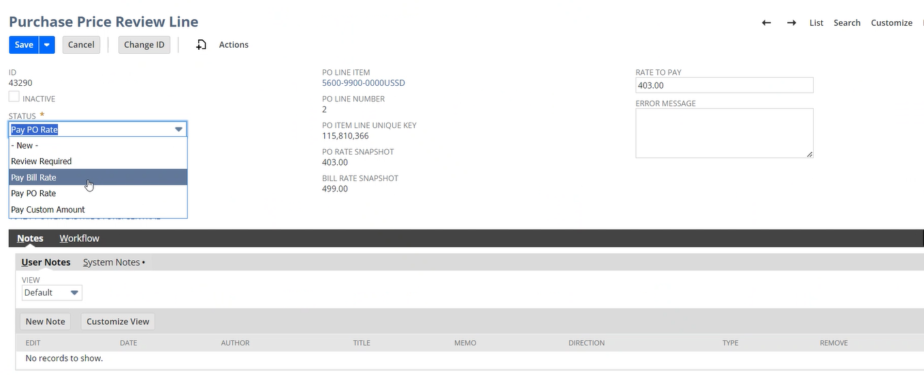

Assumptions
Will need to consider implications on final configuration of 3WM workflow.

Scenarios & Examples
Here are a couple representative examples of this design:

Purchase Price Review custom record will look similar to the following:
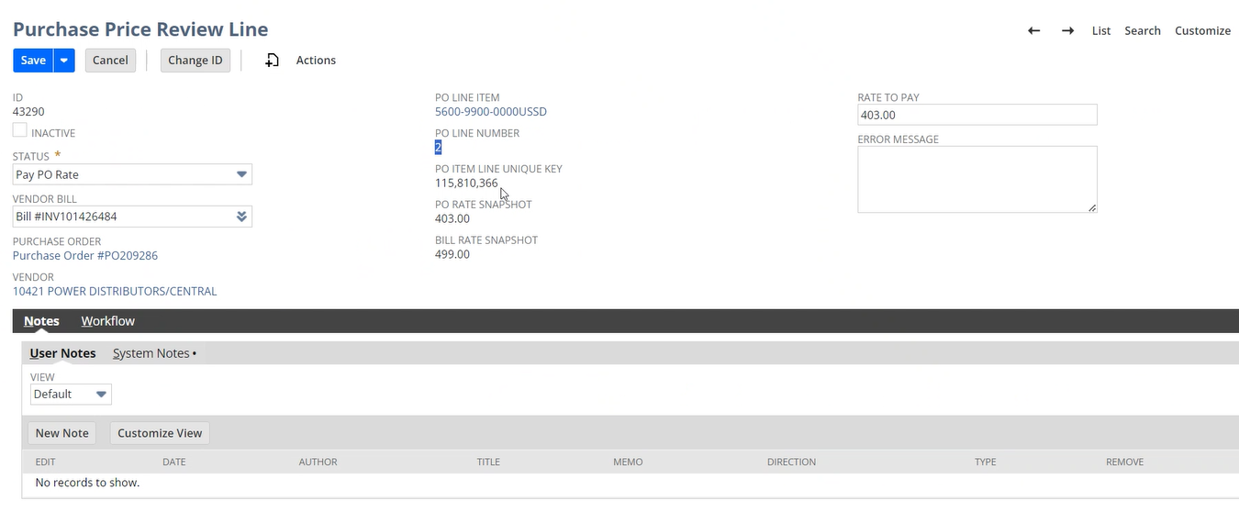

Purchase Price Review subtab and sublist on Bill record with associated sub records for each bill line:
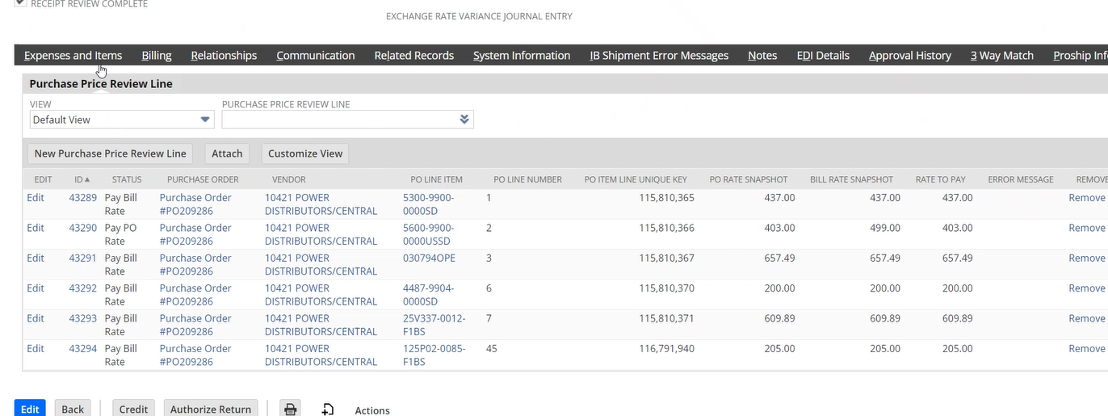

Estimate
Phase-Task | Low/High Hours
Documentation | 2-3
Technical Analysis | 1-2
Development | 12-24
Unit Testing | 4-6
Estimate Totals | 19-35

Acceptance
All development or functional work cannot be scheduled until after this document is executed.

Functional Design Approval
This approval indicates that the modification functional design meets all required company requirements.

Client Name

________________________________
Name

Date: ___________________________

